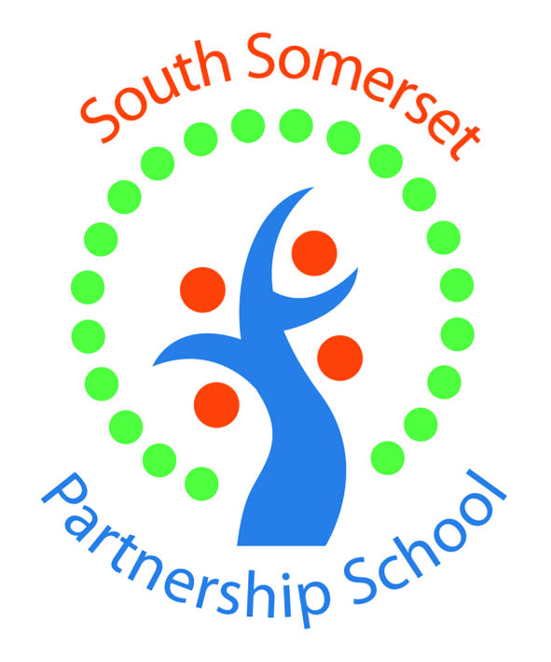

South Somerset Partnership School is recruiting enthusiastic Teaching Assistants!

This is an exciting time to join the team of staff at SSPS as we work alongside the Local Authority to promote inclusion across South Somerset.

Shortlisted candidates will demonstrate:
- the ability to work using their own initiative,
- resilience,
- and commitment to ensure that some of South Somerset’s most vulnerable children are supported to achieving the best possible educational outcomes.

SSPS is a split-site school in Yeovil and Chard and provides full and part-time placements for students with Social Emotional and Mental Health needs (SEMH). We have a full-time role based in Yeovil with secondary age pupils. As part of this team, you will work alongside pupils excluded from, or at risk of permanent exclusion or those with medical and mental health difficulties which prevent them from accessing mainstream education. The school is maintained by the Local Authority and this provides access to ‘My Staff Shop’, a savings portal, and bike to work scheme. The school provides an employee assistance programme which includes access to physiotherapy, counselling, debt management advice and loads more.

Actual Salary £21565 - £23351 term time only (£25183 – £27269 FTE with pay award pending)

All posts are fixed term until 31/08/2026 (in the first instance) term-time only and all applicants are subject to enhanced DBS check.

Please apply online at https://dasjobs.co.uk/

Please submit completed application forms to Claire Brand – School Business Manager at: Claire.brand@ssps.org.uk. 01935 410793.

Closing date: 18th July 2025 to start September 25 – interview date w/c 21/07/2025

We reserve the right to close this vacancy early if we receive sufficient applications for the role. Therefore, if you are interested, please submit your application as early as possible.

