12 December 2019

Dear Parents/Carers

As we come to the end of 2019, we would like to let you know that on Friday 20th December 2019 students will be finishing their day at 12.15pm.

Students who come to school by taxi will be collected from their centres at 12.15pm and students that walk will leave school at 12.15pm. If students normally arrive by taxi and you wish to collect them from school at 12.15pm or let them go home an alternative way, please can we ask that the school is informed by 9am.

Students return to school on Tuesday 7th January 2020.

We would like to take this opportunity to wish you a Merry Christmas and a Happy New Year.

Yours Sincerely

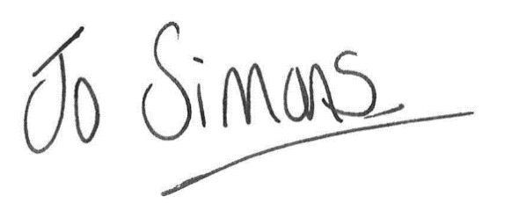

Jo Simons
Head Teacher

