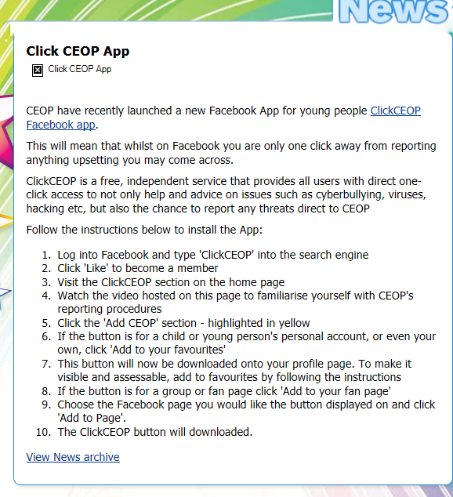
Please click the link below for more details and to get the app:
http://www.respectnotfear.co.uk/news/168-click-ceop-app.html

