English Literature– Jess Moss
Daily Work Log

Date | Work & Activities
Tuesday 31 March 2020 | 1) Continue to read stave 4 and 5 of A Christmas Carol if you haven't already done so.  2) Finish jotting down some notes on how Scrooge character changes from Stave 1 to Stave 5.  Year 11 work - carrying on with the following tasks set from last week.  1) Read chapter 3,4 and 5 of Animal Farm.  2) Click on the following link to watch the film Animal Farm:  https://www.youtube.com/watch?v=cGzRf0Ow1qU  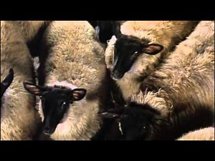 Animal Farm film 1999 Animal Farm TNT version 1999 www.youtube.com  3) Jot down what you liked and disliked about the film. Who were your favourite characters? What mark would you give the film out of 10 and why?  I will be in touch to see how you got on.
Thursday 2nd April | Now you have read A Christmas Carol you can now complete the following tasks:  - Make a storyboard showing the main events of the story.  - Create some illustrations of each of the spirits that visit Scrooge.  - Over the Easter holidays maybe watch a film version of A Christmas Carol  Year 11 Animal Farm  I do hope you have enjoyed watching Animal Farm on You Tube.  1) Over the holidays you can finish reading the book /find an audio book recording on line.  2) What is the significance of the character of Squealer in Animal Farm? I will send you an attachment on how to answer this exam question.

