21st May 2020

Dear Parents and Carers,

You may have seen reports on the news and on social media about the ‘re-opening’ of schools from 1st June and I wanted to let you know how that affects your child whilst they are on role at South Somerset Partnership School.

SSPS has not been closed during the Covid 19 pandemic, pupils who are deemed vulnerable have been provided with ongoing face to face support, and all our pupils have been accessing remote learning. Our colleagues at Children’s Social Care, Health, the Police and the Family Intervention Service (FIS) have contributed to discussions about how we meet pupils’ needs during this time. It is thanks to you as parents and carers that this remote learning has been a success and I am grateful to you for working with the staff in order to ensure your child has the best possible experience.

The time has now come for us to extend our provision and to start to invite pupils into school to complete some face to face time with our teachers and teaching assistants and I know my pastoral team have been contacting you about what we are able to offer. This is in addition to the remote learning offer which will continue for pupils throughout next term.

SSPS will have 2 additional INSET days on 1st and 2nd June. This is to allow staff to ensure our environment meets the guidance issued by the DfE and Public Health England.

I would encourage you to allow your child to access this provision. In order to ensure it is safe, all social distancing measures will be adhered to and, in our medical and mental health provision (Upper School) all pupils will be treated as Protected Persons. If your child has a shielding letter, you should let us know and they should not come to school. If another person in your home is ‘shielded’, or if your child is placed in another Centre but is ‘protected’, then all measures will be in place to ensure their safety. However, in these instances, you may choose not to send your child to school. Please discuss what is right for your family with your Pastoral Lead and, if you have one, your social or FIS worker. All attendance penalties have been suspended for the time being.

The one thing I am unable to control is the compliance of other users of the site. I attach an updated annex to our Behaviour Policy and I would ask that you take a moment to read it and be clear with your child about what our expectations are. We have a small number of pupils who have deliberately broken social distancing rules as set out by the government. For the safety of all our users, pupils and staff, this will not be tolerated. Older pupils will be asked to leave the site immediately and we will inform you straight away should this happen. If it becomes a persistent issue that we cannot resolve, I will work with other agencies to create a package of education that means they do not access on site provision at all. If you have any concerns about the behaviour of other pupils when your child is on site - please contact us immediately so that we can take action and keep your child safe.

I would ask that you join me in thanking all of our staff for their ongoing commitment to your child’s education and well-being during this difficult time. I have been humbled by the dedication and passion that has been demonstrated by all my staff and, when I next go out and ‘clap for carers’ I will be holding them in mind. Please join me in doing the same.

Finally, thank you to all of you for working with us. I know we haven’t always got it right, but your open and honest relationships with your contact staff member means that we have a firm foundation to build on as we move into the final part of this school year.

I wish you all a restful half term.

Best Wishes

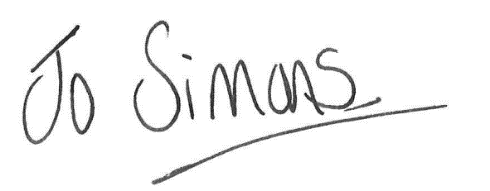

Jo Simons
Headteacher

