PRIMARY
Communication & Language | Physical & Sensory
What’s on your mind hat  Sometimes it is hard to talk about our worries and feelings.  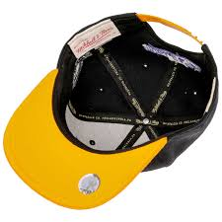  A very effective way to help with this is to use the  What’s on your mind hat!  Once a week everyone in the house writes down things that are on their mind on a scrap of paper. Firstly fold it up and put it in the hat. An adult reads out what is written on each bit of paper, one at a time. Together all the people involved look for solutions to the problem or issue.  The golden rules are that ‘hat time’ is safe, everyone gets a say, it is a calm, kind space to talk and to be listened to.  The aim is that issues, problems and worries can be understood and maybe resolved without conflict. No one is allowed to raise their voice. Only one person talks at a time. | Physical  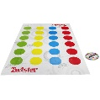  Play Twister: You can either play the official Twister game if you have it, or if you don’t, then you can paint or draw some spots on a bed sheet or large piece of paper and label them with the colours!  Sensory – Make your own paintbrushes  All you need is some twigs or pegs, string  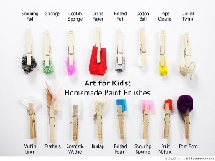  (or a rubber band) and some materials for  brushes (leaves, grass, flowers or tree  buds). Wrap the rubber band or string several  times around the handle and the natural  material, then tie it firmly and cut off any  excessive string. Or peg the material into a  clothes peg. You’ve just made your very own  brush! Enjoy creating!
Learning - Working Memory | Managing our Feelings
Coin match.  Set up a line of coins. Start with 3 and work up to 10. Place the coins in a random pattern of heads or tails. Child stares at coins for 10 seconds. Parent removes coins and hands to child who attempts to arrange them in the same order. Make this more difficult by using different types of coins.  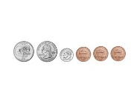  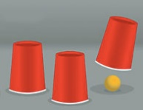  Magic Cup Game.  Place three identical plastic cups in a line on the table, rim down. Place a pom pom or small rubber ball under one cup, allowing your child/parent to see which cup the pom pom/ball is under. Shuffle the cups around by sliding them across the table, switching their positions quickly back and forth and all around. Once you have stopped moving the cups ask your child to identify which cup the ball is now under. | Outdoor art – relaxing and expressing in nature.  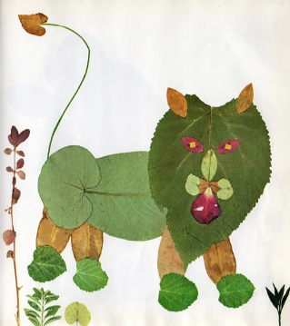  Take a walk to a local park (or use your garden) to create your own natural piece of artwork. Start by gathering leaves, twigs, feathers, stones...anything you can find. Find a sheltered space and begin arranging the materials on the floor to make your own masterpiece. You could create a magical beast, an abstract pattern or anything your imagination desires!  Why not take a favourite story with you  and cuddle up under a tree with a parent  or sibling who can read it to you?
Upcoming events/useful links
- Somerset Parent Carer Forum is asking parents and carers of children and young people aged 0-25 years with Special Educational Needs and/or Disabilities (SEND), to take a survey. Please follow this link to share your views. https://choices.somerset.gov.uk/025/send-inspection-update-please-take-the-survey/
- Somerset's Coronavirus helpline 0300 790 6275.
- If you would like to speak to an Educational Psychologist with any concerns arising for you, or your family during this time they are able to offer support. Please email - EPShelpline@somerset.gov.uk, leaving your name, school name and times you are NOT available to talk. You can also call 01823 357000 but waiting times may be longer.

SECONDARY
Communication & Language | Physical & Sensory
What’s on your mind hat  Sometimes it is hard to talk about our worries and feelings.  A very effective way to help with this is to use the  What’s on your mind hat!  Once a week everyone in the house writes down things that are on their mind on a scrap of paper. Firstly fold it up and put it in the hat. An adult reads out what is written on each bit of paper, one at a time. Together all the people involved look for solutions to the problem or issue.  The golden rules are that ‘hat time’ is safe, everyone gets a say, it is a calm, kind space to talk and to be listened to.  The aim is that issues, problems and worries can be understood and maybe resolved without conflict. No one is allowed to raise their voice. Only one person talks at a time. | Helping each other – Teamwork and physical activities  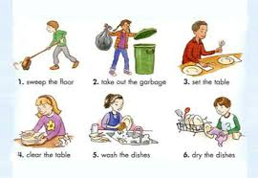  Introducing the idea of doing small jobs around the house can be a good way to teach teenagers about responsibility and that we are all part of a team that should share the jobs around the house.  These jobs might be…  Hoovering, taking the rubbish out,  washing the dishes, changing the bed sheets  weeding in the garden/cutting the grass, car washing  Benefits  Learning new skills, increased responsibility, resilience, team work, pride, sense of community and belonging.  You might even want to connect these activities to earning pocket money?
Learning - Working Memory | Managing our Feelings
Fixing something that is broken  Fixing something together can be a good bonding experience between adult and teenager, especially if the broken item belongs to the young person!  It often takes two people to fix something. One to hold, the other to glue. One to hold the nail, the other to hit the nail with the hammer.  Teaching vital skills, like how to fix a puncture or tightening the brakes helps teenagers grow in confidence and promotes independence and a ‘can do’ attitude.  It also involves following instructions, taking turns and communicating with one another effectively. | Novelty – creating new experiences in challenging ways to stimulate senses and emotions.  Why not google ‘roller coaster rides’ and try out a virtual one whilst we are still not able to do these in our real lives? It will be like a simulator in your own living room!  Creative exploration – seeing the world through a new lens.  Create a photo montage of all your friends for your bedroom wall. If you haven’t got any photos, why not send a postcard or letter to someone who you are missing? Make a pledge to take a special picture together once we are able to.
Upcoming events/useful links
- Somerset Parent Carer Forum is asking parents and carers of children and young people aged 0-25 years with Special Educational Needs and/or Disabilities (SEND), to take a survey. Please follow this link to share your views. https://choices.somerset.gov.uk/025/send-inspection-update-please-take-the-survey/
- Somerset's Coronavirus helpline 0300 790 6275.
- If you would like to speak to an Educational Psychologist with any concerns arising for you, or your family during this time they are able to offer support. Please email - EPShelpline@somerset.gov.uk, leaving your name, school name and times you are NOT available to talk. You can also call 01823 357000 but waiting times may be longer.

