[](https://www.google.co.uk/url?sa=i&url=https://www.victoriabid.co.uk/our-news/get-involved-in-steam-week/&psig=AOvVaw1lt1GghhdttNpFr1M6Jx5V&ust=1592395503188000&source=images&cd=vfe&ved=0CAIQjRxqFwoTCIjew-alhuoCFQAAAAAdAAAAABAP)

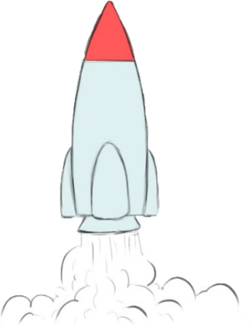

**STEAM WEEK 22.6.20 – 26.6.20**

<https://www.youtube.com/watch?v=fH5iLx_jCUk>

What is STEAM?

STEAM stands for Science, Technology, Engineering, Art and Maths. Next week is our school STEAM week, even though you might be at home you can still join in with some of the activities.

We encounter STEAM in lots of different subjects. STEAM activities help us become great creators, thinkers, problem solvers, doers, communicators and inventors.

Below are some great websites to get you started !!

Home learning links

[www.sciencebuddies.org](http://www.sciencebuddies.org)

[www.kids.nationalgeographic.com](http://www.kids.nationalgeographic.com)

[www.spaceplace.nasa.gov](http://www.spaceplace.nasa.gov)

[www.exploratorium.edu](http://www.exploratorium.edu)

[www.funology.com](http://www.funology.com)