**E-safety bulletin for parents.**

**Bulletin 1 – February 2021**

**TikTok Family Settings**



Although TikTok has an age limit of 13, we are aware - as with most social networks - which pupils of all ages use it and its popularity has grown hugely during the two lockdown periods in 2020. TikTok say they've *'taken a number of steps over the past year to improve and enhance our teams, policies, controls, and educational resources.'*  
  
They have also introduced 'Family Pairing' which allows a child's TokTok account to be linked to their parent's, giving them control over Screen time, Content and Messaging.  
  
Full details can be found at:   
<https://newsroom.tiktok.com/en-us/tiktok-introduces-family-pairing>

**Netflix Parental Controls**



Many families use Netflix as one of their main sources of viewing, with adults and children enjoying the choices available and being able to watch what you want, when you want.  
  
For parents and carers, it's vital to supervise what our children are watching and use the settings available to reduce the risk of them coming across inappropriate or upsetting content.  
  
Netflix has its own guide to using Parental Controls at:   
<https://help.netflix.com/en/node/264>

**MeeTwo app**

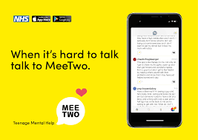

The MeeTwo app provides a safe and secure forum for teenagers wanting to discuss any issue affecting their lives.

You can anonymously get advice from experts or other teenagers going through similar experiences in areas such as mental health, self-harming, relationships and friendships.

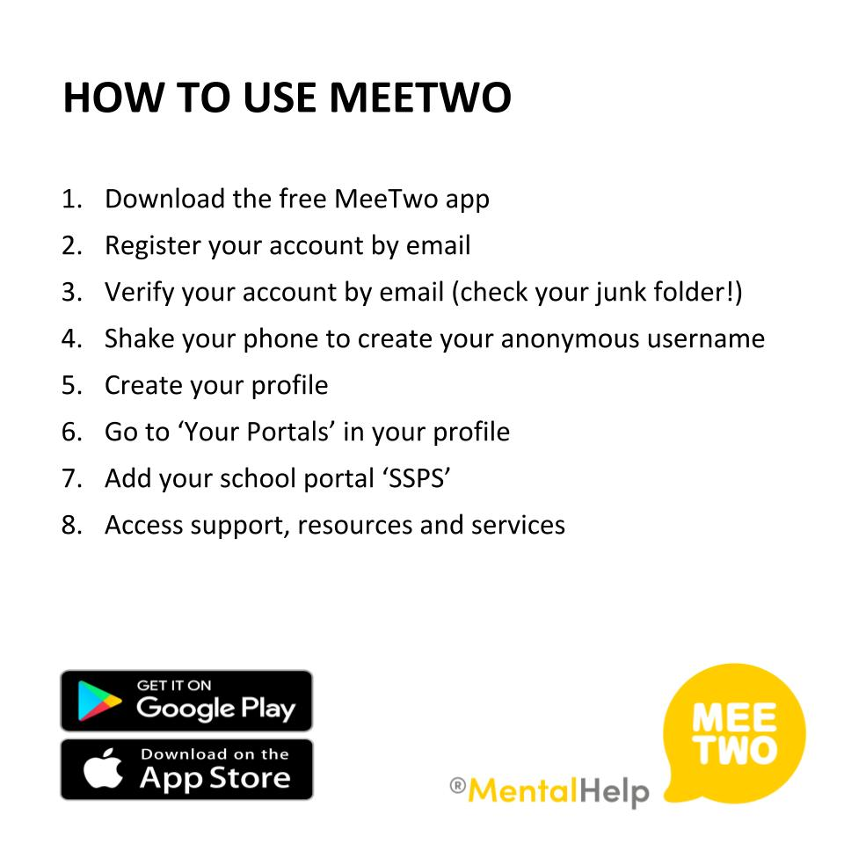

If you have any worries or concerns about your children’s e-safety then please do get in touch with the school as we are happy to help in any way we can.

 01935 410793