South Somerset Behaviour Partnership

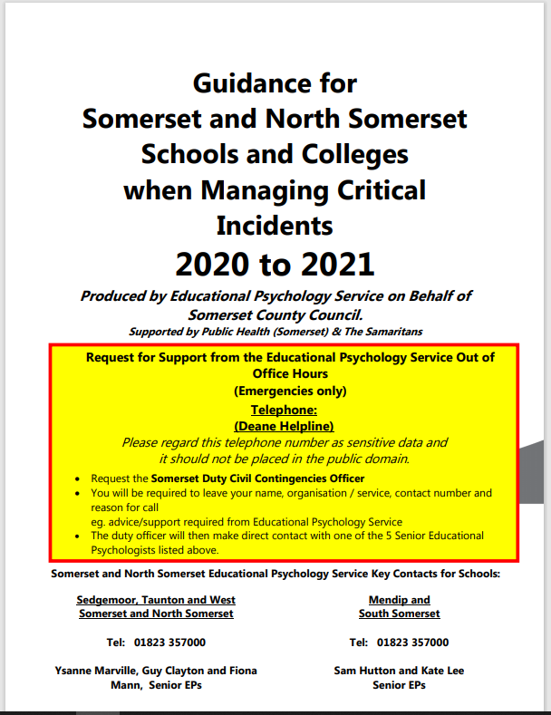

Education Psychology Service
Critical Incident Guidance

