South Somerset Behaviour Partnership

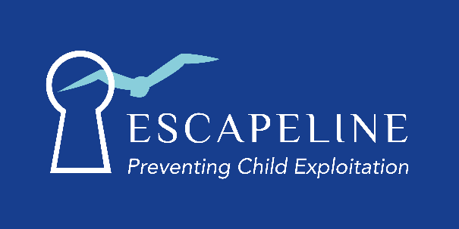

Escapeline
www.escapeline.org.uk

We provide school assemblies and workshops for pupils in Years 5 to 13, developing understanding of county lines and child exploitation.

Escapeline offer a youth worker and mentor (ex gang member) to carry out detached youth work with young people identified as being at risk or on the cusp of being exploited by county line gangs.

Our work involves building positive relationships with young people either as a 2-1 or small group, providing education and developing awareness of child exploitation and criminal gangs.

Escapeline provides 1-1 telephone support for parents whose children are being criminally or sexually exploited by county line gangs. The service provides confidential, independent, non-judgemental support.
Alongside the parental support line, Escapeline also provide awareness and educational sessions on child exploitation and county lines to parents.

Email – enquiries@escapeline.org.uk to request a referral form.

www.escapeline.org.uk

