**South Somerset Behaviour Partnership**

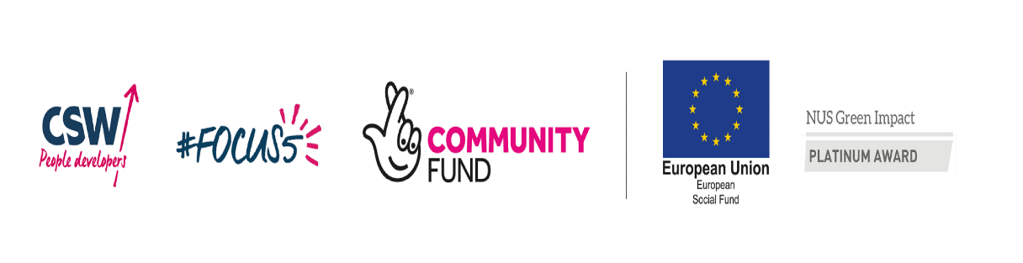

|  |
| --- |
| **#Focus5**  (Careers South West Group Ltd) |
| **#Focus5** offers a range of support for young people who are NEET or at risk of NEET, to help them make decisions towards their next steps in education, training, or employment, and to overcome their personal barriers to progress. |
| Referral is easy and anyone can refer a young person who they think will benefit from support with their future steps.  Use the link below to access our webpage.  <https://www.cswfocus5.co.uk>  click on Referral form on the top bar.  Complete the form online and this gets sent to our administrator, who will make initial contact within 2 working days. |
| <https://www.cswfocus5.co.uk>  *Sandy Coggan, Administrator*  *Marie McNaught, Administrator* |