South Somerset Behaviour Partnership

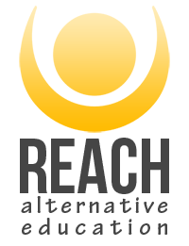
Reach Alternative Education
www.reachyouth.co.uk

Alternative Provision in Somerset offering one to one and group placements for students in KS2 – KS5.

We have a team of youth workers who work alongside students to help meet need. This is through creating safe connections and environments that promote development.

Referrals can be made through our website www.reachyouth.co.uk

No referral criteria and no waiting lists

Or contact our duty number on 07966 281959

