Our Remote Art Offer for Partnership Schools

Our Art Practitioner, Charlotte Rupp, has been creating a selection of art videos which are uploaded here to support staff and students in schools.

We have also provided resources to extend this video in the hope that the therapeutic art work with Charlotte can be continued in some form whilst we cannot be with you.

Click the links below to access the art videos.

WEEK 1– Galaxy Art
https://m.youtube.com/watch?v=_On3r8iTQ4M

WEEK 2 - Felt Flowers
https://www.youtube.com/watch?v=geMd1_0GLc0

WEEK 3 - Simple watercolour backgrounds
Simple watercolour backgrounds

WEEK 4 - Colour Mixing, Jewel Painting
https://m.youtube.com/watch?v=DSiC-zVkZVc

What is a Galaxy?

A galaxy is a group of stars, clouds of gas, and dust particles that move together through the universe. There are billions of galaxies in the universe. They probably formed billions of years ago, soon after the universe began. The sun, Earth, and the other planets of the solar system are part of the Milky Way galaxy.
Here are some sample galaxy pictures to provide you with inspiration!
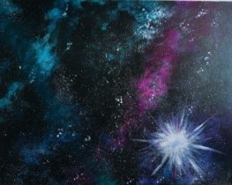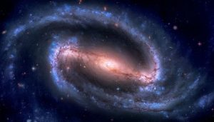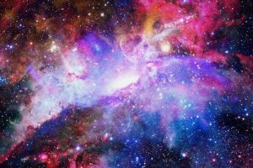

Stories, podcasts and more about space and galaxies to share –

Younger children - https://www.bbc.co.uk/cbeebies/radio/hear-to-there-the-moon

Older children – Aliens Love Underpants - https://www.bbc.co.uk/bitesize/topics/z74n6v4/articles/zbm2qp3

Beegu – a touching story about a lost alien –https://www.youtube.com/watch?v=OaX_zGZO0Y8

Story time from space - https://storytimefromspace.com/stories/the-incredible-intergalactic-journey-home/

A recipe for space playdough to enjoy – https://www.twinkl.co.uk/resource/t-a-114-black-sparkle-space-playdough-recipe

Useful facts and websites about space and galaxies – https://kids.britannica.com/kids/article/galaxy/353161

The American Museum of Natural History - https://www.amnh.org/explore/ology/astronomy

NASA for kids - https://www.nasa.gov/kidsclub/index.html

