South Somerset Behaviour Partnership

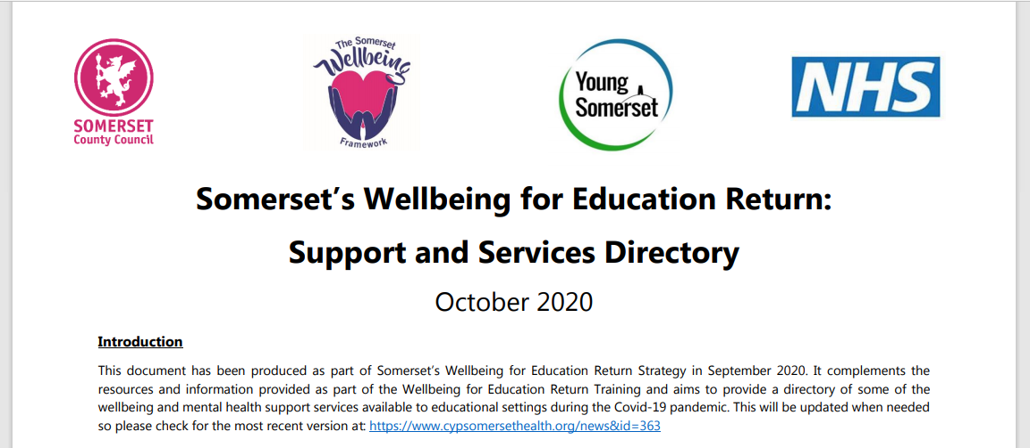

Somerset children & young people : Health & Wellbeing : News (cypsomersethealth.org)

