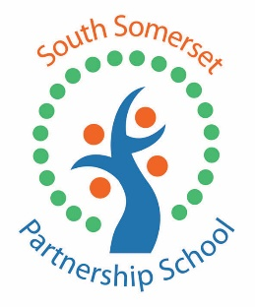

**South Somerset Partnership School is recruiting enthusiastic Teaching Assistants**

**and a Primary Teaching Assistant (Play Lead) for our Outreach and Capacity Building Team**

This is an exciting time to join the team of staff at SSPS as we work to promote inclusion across South Somerset.

Shortlisted candidates will demonstrate the ability to work using their own initiative and be committed to ensuring some of South Somerset’s most vulnerable children are supported to achieving the best possible educational outcomes.

**Teaching Assistant initially based in Chard (KS4) – Grade 13**

Our Chard site provides full time and part time placements for pupils in Years 9-11 with Social Emotional and Mental Health needs (SEMH) who display challenging behaviours.

As part of a small team you will work alongside pupils who have been, or are at risk of, permanent exclusion.

Actual Salary £18811-£20598 term time only (£21968 – £24054 FTE with pay award pending)

**Teaching Assistant (Play Lead) Full Time – Grade 13 (part time 22 hrs 0.6FTE)**

We provide significant outreach support to schools in South Somerset, and our partners identify this as an area of significant strength in our school. Our purpose is to support schools in building their own capacity to work with children and young people who display behaviours that challenge. We also provide more intensive and regular support for children where appropriate and have some resource that can be allocated to schools to help.

The successful candidate will have worked with children in Key Stage 1 and 2 using creative and / or play based interventions to prepare them for learning in a mainstream classroom.

Knowledge of the ‘Thrive’ framework would be an advantage.

Actual Salary £11286-12358 term time only (£21968 – £24054 FTE with pay award pending)

All posts are fixed term until 31/08/2024 (in the first instance) term-time only and all applicants are subject to enhanced DBS check.

See our website for more details [www.ssps.org.uk](http://www.ssps.org.uk)

Please apply online at <https://dasjobs.co.uk/>

Please submit completed application forms to Claire Brand – School Business Manager at: [Claire.brand@ssps.org.uk](mailto:Claire.brand@ssps.org.uk). 01935 410793.

Closing date: Monday 30th October, Interviews 2nd and 3rd November.